IT242 | Project 2
Score: ______/100 | v1.1

Specifications

Create a fully functional and visually appealing Audio Media Player using Jetpack Compose. The app must support audio playback, navigation between screens, and metadata extraction from audio files.

Core Functionality

- Audio Playback:
  - Play audio files from local storage.
  - Include a slider/scrubber that shows current playback position and allows drag-to-seek (fast-forward/rewind).
  - Include Pause and Resume buttons.
  - Include a Looping Mode (repeat single song or entire playlist).
  - Include a Volume Control Slider inside the app UI.
- Metadata Handling:
  - Automatically extract metadata from audio files (e.g., title, artist).
  - Display this information on the control screen.

UI & Navigation

- Implement 2 distinct screens:
  - Song Selection Screen: List all available songs from local storage.
  - Now Playing Screen: Show current song, playback controls, and extra credit album art.
- The app must be visually polished (not a default-themed, unstyled prototype).
- Use appropriate colors, spacing, and typography.
- Show the user what’s playing and what’s next.

Constraints

- Use Jetpack Compose only (no XML layouts).
- Write primarily Kotlin code.
  - Some Java is acceptable.
- An app icon is required – the default placeholder icon is not acceptable.
- Your GitHub repository must have a README.md file.
- Store audio files in the src/main/assets directory.
- Do NOT include actual audio files in your GitHub repo.
  - Create a .gitignore that excludes audio files (e.g., *.mp3, /app/src/main/assets/, etc.).
  - Mention in your README that audio files must be manually placed in the correct directory.
- Follow Android best practices (lifecycle-aware components, state management in Compose, etc.).
Extra Credit

- (+4 pts) Display album art (if available via metadata).
  - If some audio files do not have associated album art, display a placeholder.
- (+3 pts) Add a light/dark theme toggle in the application.
- (+4 pts) Add a “Now Playing” notification with playback controls.
- (+10 pts) Playlist Functionality:
  - Users can view and play a playlist.
  - Playlist should support shuffle playback.
  - Playlists must be saved to device storage using DataStore so they persist across app restarts.
  - Playlist Screen: View and manage the current playlist.

Submission

Submit the commit ID of the specific commit you wish to turn in for this assignment.

Academic Honesty Policy

All code submissions must be original and authored by the student. While students are allowed to GitHub Copilot as coding assistants, these tools should be used for guidance and productivity enhancement, not as a replacement for understanding or writing code. Simply copying and pasting AI-generated code without comprehension or modification is not acceptable.

Any code sourced from another student, falsely presented as one’s own, or copied directly from third-party websites will constitute a breach of the school’s academic honesty policy.

Daily commits and pushes to your assignment GitHub repository are mandatory while working on your project. Failure to comply will result in deductions from your final grade at minimum, and could lead to academic honesty violations.

Tips

- Consider working in this order:
  - Start by loading and listing audio files.
  - Add basic playback.
  - Implement screens and navigation.
  - Finally, refine UI and add advanced features.
- Remember to preview your composables for quick feedback.

How to Create the src/main/assets/ Directory

1) Right-click on your project directory (likely displayed as “app” in Android Studio).
2) Select New>Directory.
3) Search “assets”
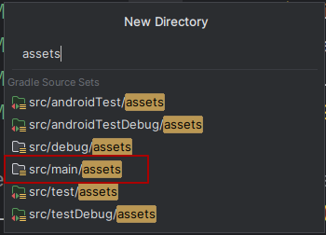
4) Select src/main/assets
5) Place audio files in this new directory.

Here is a snippet of code showing how you can use the “assets” directory:
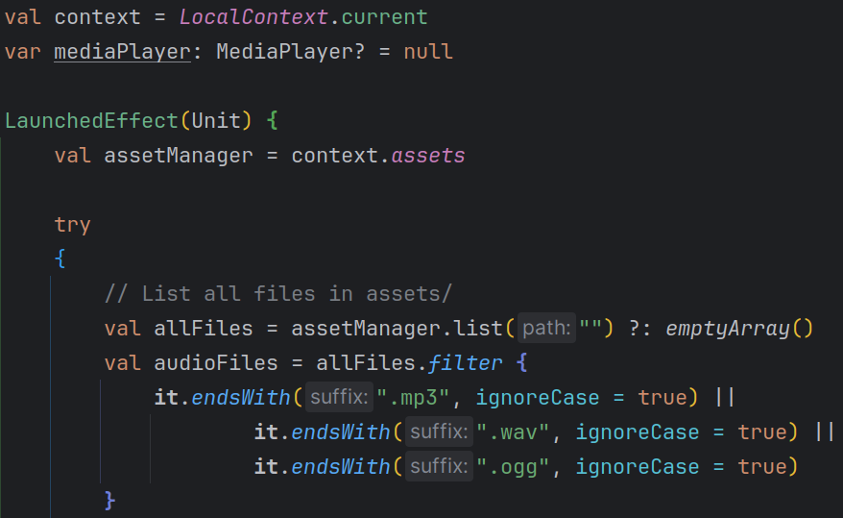
(You will likely want to use LaunchedEffect in your code. It is a side-effect API in Jetpack Compose. It lets you run code once when a composable appears on the screen.)

